Tapestry at Bletchingley Village Primary School
All children in the Early Years at Bletchingley Village Primary School have a personal online learning journal with Tapestry. On Tapestry you will find photos, videos, and written observations about your child, shared by the Early Years team at Bletchingley. You will also be able to add your own entries to share your child’s learning, achievements, and adventures from home too, which we can talk about with the children in school! All information on the Tapestry platform is stored securely and can also downloaded at different points throughout the school year.
The Early Years team may also use Tapestry to share general class information, videos and home learning too, so it is important for you to check in regularly, so you don’t miss out. You can opt to receive emails when an entry is added to your child’s learning journal so you can keep in the loop.
In order for you to access your child’s learning journal please complete the Tapestry Agreement form with your chosen email contact and we will create you a parent account. If you have more than one child within the Early Years at Bletchingley, you will be able to see all their separate learning journals when logging in. If parents/ carers require more than one login, each parent/ carer will need to complete their own permission form/ agreement.

A Guide to Tapestry for Parents/ Carers

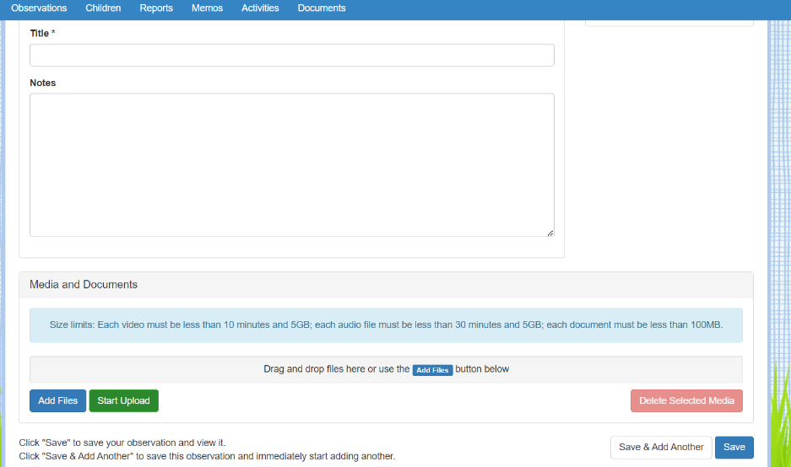
How to… Add an Observation.
Via the website…
- Click Observations. Click +Add Observation. You will need to add a Title and then some information in the Notes section. If you wish to add photos/videos to share you can click Add Files, select from your photo/computer gallery and then click Start Upload.
- When finished, click Save.
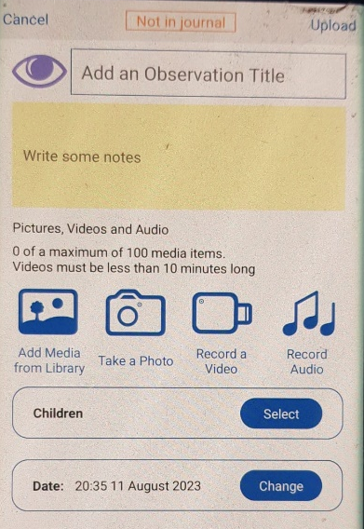

Via the app…
- Click the + in the top right-hand corner. Add the Title and write any information in the Notes section.
- Where it says Children, click Select and then tap your child’s name. Click Done.
- To add photos or videos, you can click Take a Photo, Record a Video or Record Audio, or you can click Add Media from Library to upload photos or videos from your gallery.
- When finished, click Upload. It will not let you upload without a title.

What should I upload?
We love hearing about adventures and learning opportunities from out of school. Have you been on holiday or been somewhere exciting such as the zoo? Has your child mastered a new skill such as riding a bike? Have they gained a swimming badge or a gymnastics medal? Have they shown you some of their learning at home e.g., writing a Christmas card, counting their cars, reading a shop sign?
If you upload to Tapestry, we can discuss the media/ information you share with your child, and they can talk about it to their peers if they wish. We are grateful when you share observations from home, as it shows your child that learning can take place anywhere- not just at school!

How to… respond to our observations from school.
- When you click on an observation, scroll down and press Add a comment. Type in the Enter Comment… box and click Save.
- To like an observation, click the thumbs up/ Like button under the observation notes. Please can you give each observation a like, so we know that you have seen it.

How to… Change your account information.
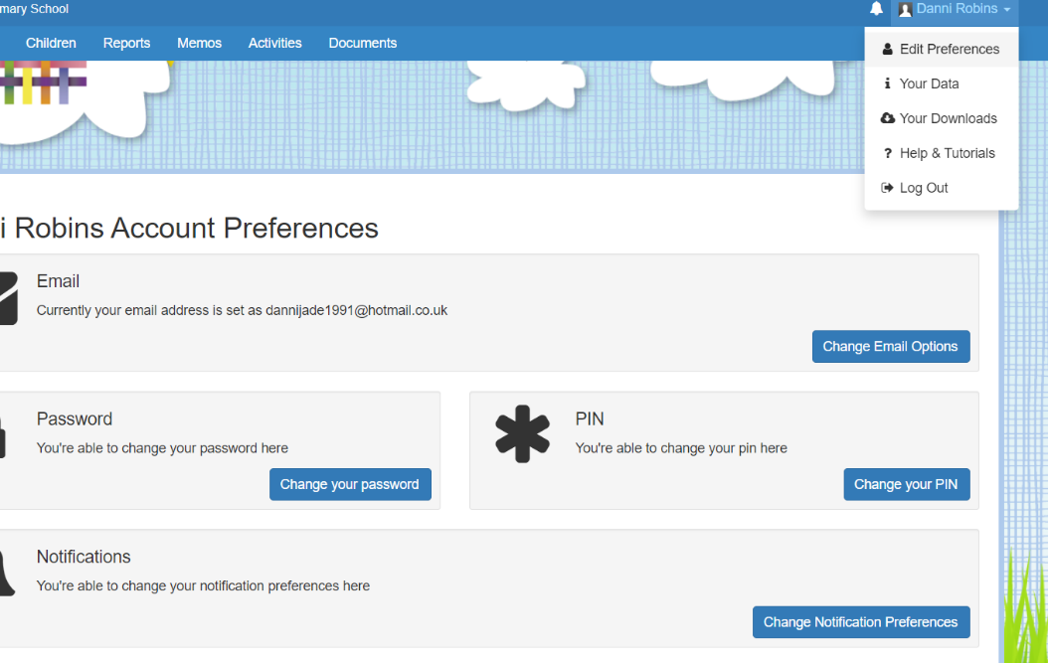
- Log in via the website https://tapestryjournal.com/ using your chosen email address and the password given by us.
- In the top right-hand corner, click your name and then select Edit Preferences. Here you can change your chosen email, your password and/or your pin.
- In the Notifications section, you can change how regularly you receive emails from Tapestry.

You will receive an email when an observation or a memo is added for your child. Every Friday, Reception parents will also receive a weekly overview- sharing current learning in school from the week, any home learning opportunities, and any reminders of upcoming events. Please login to the app/ website regularly, so you don’t miss any updates. If for any reason, you are unable to access your Tapestry account, please speak to your child’s class teacher as soon as possible, so we can keep everyone in the loop, or email Mrs Barlow d.barlow@bletchingleytlt.co.uk.
Thank you for your continued support

