Wordless Books Guidance for parents/ carers

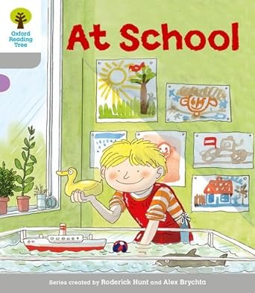
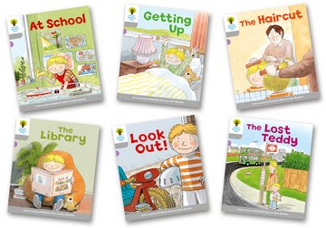
During the first part of the autumn term, your child will bring home wordless books. Please read the guidance below to find out why these books are beneficial for your child and how to support them with reading them.

Why are wordless books beneficial?
Sharing wordless books is a fantastic way of building important literacy skills, including listening skills, vocabulary, comprehension and an awareness of how stories are structured. Wordless books are told entirely through illustrations and engage children in prediction, critical thinking, meaning making and storytelling.

Top tips for sharing wordless books with your child
1. Begin by looking at the cover. What can you see? What clues to the story does the cover illustration show?
2. Read the title. Does the title give you any ideas of what the story might be about? Make predictions about the story based on the cover and title.
3. Take a picture walk. Look through the pages of the book with the sole purpose of enjoying the pictures. Talk about anything that captures your attention.
4. "Read" the story. You might go first, inviting your child to add to your story as they see fit. Don’t be afraid to tell your story with dramatic flair. Add sound effects and interesting voices that suit the characters of your tale.
5. Encourage your child to take a turn telling their own version of the story, using the pictures and turning the pages as they go.
6. Ask questions about the book — which is your favourite illustration? Who are the characters? Do you have a favourite part of the story or a favourite character? Can you tell me about a time you have felt like the main character or found yourself in a similar situation? Where does the story take place? What do you think might happen next? How are they feeling- why are they feeling that way?

